

KENYA METHODIST UNIVERSITY
SCHOOL OF COMPUTING AND INFORMATICS
DEPARTMENT OF INFORMATION TECHNOLOGY
UNIT CODE: BBIT 411
UNIT TITLE: RESEARCH PROJECT PROPOSAL
RESEARCH TOPIC: REDBUBBLE MERCHANDISE BRANDING MOBILE APPLICATION
PRESENTED BY: Hiram Karomo Kamau
REGISTRATION NUMBER: BIT-1-0967-3/2023
SUPERVISOR: Peter Waweru
Submitted by Hiram Karomo to Kenya Methodist University in partial fulfillment of the requirements for the degree in Bachelor of Business Information Technology

Date of Submission: NOVEMBER, 2025

DECLARATION

DECLARATION BY THE CANDIDATE.
This research project, which is my original work, has not been presented for a Degree in any other University. No part of this research may be reproduced without the prior permission from the author and/or Kenya Methodist University.
Students Name: Hiram Karomo
Signature …………………………….
Date ………………………………….

DECLARATION BY SUPERVISOR(S).
This research project has been submitted for examination with our approval as University Supervisors.
Supervisor’s Name: Mr. Peter Waweru
Signature …………………………………………….
Department: Computer science
Date ……………………………………………………

ACKNOWLEDGEMENT
I would like to express my sincere gratitude to the Almighty God for granting me good health and the mental fortitude required to complete the Redbubble Merchandise Branding Mobile Application project. I am truly grateful for the physical and spiritual wellbeing that enabled me to undertake and finish this work.
I extend my heartfelt appreciation to my supervisor, Mr. Peter Waweru, whose invaluable guidance, support and expertise were instrumental throughout the entire research and development process. His patience, constructive feedback and unwavering dedication have been truly commendable and I remain deeply grateful for his mentorship.

ABSTRACT
This research proposal presents the development of a Redbubble Merchandise Branding Mobile Application designed to simplify and centralize the process of creating and ordering custom branded merchandise for weddings, social groups, and non governmental organizations (NGOs). The proposed solution is a mobile based platform integrated with Redbubble’s print on demand (POD) system, allowing users to easily design, customize, and place bulk or on demand orders for items like t-shirts, caps, and hoodies through a simple, user friendly interface. Key features include a bulk order management module for flexible quantities and pricing, real time tracking, and integrated feedback loops to support collaborative design approvals. The application also incorporates analytics to help users make data driven branding decisions. In support of sustainability, the platform partners with suppliers that use eco friendly materials and reduces shipping emissions through localized fulfillment. The system will be developed using the Software Development Life Cycle (SDLC), following the waterfall methodology to ensure a structured and reliable rollout. Overall, this mobile solution aims to empower users regardless of technical background to manage branding campaigns affordably, efficiently and with a strong focus on sustainability.

TABLE OF CONTENT
DECLARATION ii
DECLARATION BY THE CANDIDATE. ii
DECLARATION BY SUPERVISOR(S). iii
ABSTRACT v
CHAPTER ONE 1
Introduction 1
1.1 Background of the Study 1
1.2 Problem Statement 2
1.3 Justification 3
1.4 Objectives 4
1.5 Scope of the Study 4
CHAPTER TWO 8
LITERATURE REVIEW 8
2.1 Introduction 8
2.2 Review of Related Work 8
2.3 Literature Gap 10
CHAPTER THREE 11
Methodology 11
3.0 Introduction 11
3.1 Methodology 11
3.2 Project Resources, Budget and Schedule 13
Chapter Four 16
4.0:Results 16
4.1 User Interface 16
4.2 Administrator Interface 16
4.3Administrator Dashboard 17
4.4 customer’s interface 17
4.5 Supplier’s interface 19
4.6 Database module 20
4.7 About Us Module 20
4.8 Help Module 20
4.9 Drivers Module 21
21
4.10 Service Manager 21
4.11 Technician Interface 22
4.12 Feedback and Support Module 22
4.13 Dispatch manager 23
4.14 Designer interface 23
4.15 Stock manager 24
4.16 Reports module 24
4.17 Payment module 25
Chapter Five 26
Conclusion and Recommendation 26
5.1 Conclusions 26
5.2 Recommendations 26
4.0 References 27

CHAPTER ONE

Introduction
This chapter introduces the research topic, providing the background of the study, problem statement, justification, objectives and scope of the proposed Redbubble Merchandise Branding System.

1.1 Background of the Study
In today’s digital era, branding has become central to how organizations and groups communicate, build identity and engage their audiences. Merchandise branding through items like t-shirts, caps and hoodies offers a visual and emotional symbol of unity and shared values. Whether used in weddings, religious gatherings, alumni events, or NGO campaigns, personalized merchandise extends the reach of a message while strengthening group cohesion and visibility.
Despite its growing relevance, traditional methods of sourcing and producing branded merchandise remain inefficient. Organizations often navigate multiple vendors for design, printing and delivery, leading to inconsistent quality, increased costs and delayed timelines. These systems usually require large minimum orders, which can result in surplus stock and financial strain, particularly for small organizations and community groups. Moreover, most suppliers still rely on non ecofriendly production processes, exacerbating environmental challenges like textile waste and carbon emissions.
Amid these constraints, print on demand (POD) platforms like Redbubble offer a modern, sustainable alternative. Redbubble provides users with intuitive design tools and handles manufacturing, fulfillment and delivery globally. This eliminates the need for upfront inventory investment, making it accessible to groups that may lack technical or logistical expertise. The platform’s distributed production model also reduces environmental impact by producing items closer to customers, thereby cutting down on emissions from long-distance shipping.
Although Redbubble is widely known in the e-commerce and independent artist communities, it is still underutilized by event organizers and NGOs who would benefit significantly from its capabilities. Most users are individual sellers rather than institutions needing coordinated branding solutions for larger events. This gap highlights the need to adapt Redbubble’s infrastructure for group-oriented use cases.
This proposal outlines the development of a Redbubble Merchandise Branding System tailored for NGOs, social groups and event planners. The system aims to streamline the process of designing and ordering custom merchandise by introducing user-friendly templates, template customization, a bulk ordering interface and order tracking capabilities. These features will simplify campaign management, reduce overhead and ensure brand consistency across all merchandise.
A key aspect of the system is its focus on sustainability and inclusivity. The platform will promote eco conscious suppliers and offer transparency through sustainability indicators like water usage, carbon footprint and material sourcing. At the same time, the user interface will be mobile responsive and accessible, making it suitable for both urban and rural users with varying levels of digital literacy.

1.2 Problem Statement
Ideal Situation
In an optimal scenario, event organizers and social groups should have the capability to effortlessly create and personalize bulk merchandise items such as T-shirts, mugs, and tote bags. They should have access to cost effective, premium quality materials with clear sustainability credentials. The ordering process should be consolidated into one intuitive platform that enables real time teamwork. Instant participant feedback mechanisms should allow for design refinements prior to manufacturing, while on demand or pre order systems would help eliminate unnecessary surplus inventory.
Current Situation
Presently, the merchandise management process is disjointed and problematic:
Organizers must juggle multiple platforms for design creation, supplier coordination, and participant surveys. Bulk purchasing typically imposes high minimum order quantities that result in unused surplus stock. Environmentally conscious material choices remain limited, with most suppliers continuing to use conventional, non ecofriendly components. The feedback collection process remains manual and inefficient, relying on basic tools like spreadsheets and email chains that often lead to communication breakdowns.

The Gap Issue
The current market faces several critical shortcomings. First, there is no unified platform that seamlessly integrates design, ordering and user feedback functions. Second, conventional bulk ordering models often encourage excessive production, leading to significant waste. Third, sustainable material options at scale remain scarce in the marketplace. Finally, current systems largely maintain a top down approach, failing to adequately engage end-users in the decision-making process.
Suggested Fixes
This study proposes a mobile application making it simpler to create and market merchandise for weddings, groups, and NGOs. The application shall be intergraded in a way that allows users to design, customize and simply order on demand or bulk orders. It will include pre made templates, real time feedback systems, and accommodate environmentally friendly materials through verified suppliers. Orders shall be shipped through partnered logistics firms to ensure quick and effective delivery. The system will be developed with the Waterfall SDLC to give a systematic and secure solution to existing, sustainable merchandise branding.

1.3 Justification
This project is justified by its ability to address the prevalent inefficiencies and challenges faced in merchandise branding, especially for small groups, organizations, weddings, and NGOs that often lack access to professional design and production services. Traditional methods of merchandise branding are often time-consuming, costly, and environmentally unsustainable. By leveraging Redbubble’s integrated design tools and global fulfillment network, this project provides an accessible and scalable platform for creating customized branded merchandise with minimal technical expertise.
Users benefit from streamlined processes from design to delivery ensuring consistent brand presentation across all products. The platform enables high-quality, on-demand production, reducing overstock and waste, which aligns with modern sustainability goals. Moreover, Redbubble’s system ensures that products are printed and shipped closer to the buyer, further lowering carbon emissions.
The project also supports greater community engagement by allowing users to co-create and personalize designs that reflect group identity, values, or causes. By incorporating data on user preferences and behavior, the platform can recommend design trends and product options that are more likely to resonate with the target audience. Ultimately, this approach enhances brand visibility and emotional connection with stakeholders, making it a valuable tool for modern branding initiatives in both social and commercial contexts.

1.4 Objectives

1.4.1 General Objectives
- To develop a mobile application for Redbubble Merchandise Branding.

1.4.2 Specific Objectives
- To create a centralized database for efficient data access and management.
- To develop an admin web panel and an interactive web interface for Redbubble Merchandise Branding.
- To develop a user-friendly front-end interface for Redbubble Merchandise Branding.
- To ensure mobile responsiveness and accessibility of the platform across all devices.
- To generate comprehensive reports for Redbubble merchandise operations and performance

1.5 Scope of the Study
The system will be constructed using existing web technologies and the Redbubble API. The system is designed to help designers, NGOs and independent event organizers manage branded merchandise through an online integration platform. The system will incorporate the following modules:

1.5.1 Special Orders Module
Allows clients to request customized or non-standard services outside typical listings, promoting flexibility and personalized service delivery.

1.5.2 Drivers Module
Manages the logistics of delivering physical products or event materials, especially useful for artisans or event-based freelancers.

1.5.3 Service Booking Module
Enables clients to schedule appointments or service sessions based on freelancer availability, integrating calendar and time-slot features.

1.5.4 Designer Module
Tailored specifically for graphic/fashion designers to display portfolios, manage orders and interact with clients.

1.5.5 Supplier Module
Facilitates the onboarding and management of product or service suppliers who support the freelance ecosystem, such as caterers or decorators.

1.5.6 Dispatch manager
Coordinates efficient orders dispatch by assigning tasks to drivers, routing deliveries on an optimal level and providing real time tracking to administrators and clients

1.5.7 Inventory and Stock Module
Allows suppliers or artisans to manage product inventory levels, ensuring accurate availability during order placement.

1.5.8 Search and Filter Module
Enhances user experience by allowing efficient searching and filtering of services or freelancers based on categories, price, rating, and location.

1.5.9 Reports Module
Generates analytics for users and administrators, including order statistics, earnings, user activity, and platform performance.

1.5.10 Admin Control Module
A centralized backend for administrators to manage users, monitor transactions, approve services, and resolve disputes.

1.5.11 Help and Support Module
Provides clients and freelancers with access to FAQs, live support, and a ticketing system for issue resolution.

1.5.12 Payment & Invoice Module
Handles secure transactions via integrated payment gateways ( Mpesa, Stripe) and auto-generates invoices for transparency.

1.5.13 Feedback & Review Module
Enables users to rate and review services after completion, building trust and accountability within the platform.

1.5.14 About Us Module
Communicates the platform’s mission, vision, and background to users, enhancing brand credibility.

1.5.15 Database Module
Supports secure, structured storage of all platform data including users, services, orders and transactions, ensuring integrity and accessibility.

1.5.16 Contact Us Module
Provides a communication channel for general inquiries or partnership proposals via a form or direct contact information.

1.5.17 Technician module
Convert designs into products through tasks like assembly, testing and quality checks.

CHAPTER TWO

LITERATURE REVIEW

2.1 Introduction
This chapter provides a comprehensive review of the literature pertinent to digital merchandise platforms, customized product branding, and sustainability in e-commerce. The rapid evolution of e-commerce has led to the emergence of various platforms that cater to the growing demand for personalized products. This review synthesizes key studies, reports, and existing systems to identify the gaps that this project aims to address. By examining the strengths and weaknesses of current platforms, we can better understand the landscape of digital merchandise and the opportunities for innovation in this space, particularly within the context of Kenya and Africa.

2.2 Review of Related Work

2.2.1 Printful and Teespring
Printful and Teespring are leading print-on-demand platforms that provide design, fulfillment, and global shipping of custom products. While they offer flexibility in design, they often lack strong bulk ordering systems, sustainability tracking, and integration with local vendor networks (Peters, 2020). In the African context, the need for localized solutions is critical. For instance, many small businesses and entrepreneurs in Kenya are looking for platforms that not only allow for customization but also support local production to reduce shipping costs and lead times. The absence of strong local vendor networks on these platforms can hinder the growth of small businesses that rely on quick turnaround times and local sourcing of materials.

2.2.2 Custom Ink
Custom Ink is known for its focus on group orders, making it a popular choice for teams, schools, and organizations. However, the platform's complexity can be a barrier for non-designers, limiting its accessibility. While Custom Ink offers competitive bulk pricing, users have reported long turnaround times, which can be detrimental for time sensitive projects (Klein & Morris, 2019). In Kenya, where many organizations operate on tight schedules, the ability to receive products quickly is crucial. In the African context, there is a growing demand for platforms that not only facilitate bulk orders but also provide user-friendly interfaces that cater to a diverse audience. The need for localized support and training is essential to ensure that organizations can effectively utilize these platforms for their branding and merchandise needs.

2.2.3 Zazzle
Zazzle is a well-established platform that allows users to create and customize a wide array of products, from clothing to home decor. It stands out for its extensive product catalog and user friendly design tools, which enable customers to personalize items easily. However, despite its strengths, Zazzle has several limitations that are particularly relevant in the African context.One significant drawback is the lack of a robust bulk ordering system, which is essential for organizations that need to place large orders for events or promotional purposes. While Zazzle does allow for customization, the process can become cumbersome when dealing with multiple items or large quantities, leading to potential errors and inefficiencies in order fulfillment (Smith & Johnson, 2021).

2.2.4 Bonfire
Bonfire is a U.S.-based platform centered around campaign-based merchandising, often used by nonprofits and small organizations for fundraising through custom apparel sales. Its user-friendly setup and automatic order fulfillment process are frequently highlighted as key advantages, especially for groups with limited technical skills (Taylor & Jordan, 2021). These strengths have made it an appealing option for non-profits, teams, and community groups in the U.S.

2.2.5 Merch by Amazon
Merch by Amazon provides a scalable, print on demand (POD) platform backed by Amazon’s robust global logistics system. Johnson and Kumar (2020) describe it as a low-barrier entry point for content creators, offering standard print features and strong analytics tools without upfront costs. Its integration with the larger Amazon ecosystem enhances product discoverability enables passive income generation through digital merchandise.

2.2.6 Apliiq
Apliiq is a POD platform that focuses on fashion-forward customization, offering services such as private labeling, embroidery, and fabric personalization. Wanjiru and Mburu (2023) note that Apliiq uniquely serves fashion entrepreneurs who seek brand identity differentiation through personalized clothing tags and woven labels. These offerings make Apliiq attractive to designers aiming for premium branding. Despite its strengths, Apliiq’s structure presents challenges for nonprofit or bulk campaign use. Its pricing model is geared toward small batch and boutique fashion production, limiting its suitability for large merchandise orders or event campaigns. Moreover, shipping restrictions to African countries and the lack of open APIs for system integration hinder its practical use in NGO and institutional settings (Wanjiru & Mburu, 2023).

2.2.7 Jet Print
Jet Print is a China-based print-on-demand platform specializing in customized fashion items and accessories such as watches, footwear, and home decor. It integrates with Shopify and WooCommerce, allowing designers and online store owners to create and sell niche merchandise with unique design capabilities. According to Chen & Zhao (2021), Jet Print differentiates itself through 3D preview tools, which help users visualize final products before ordering enhancing design accuracy and user confidence.

2.3 Literature Gap
Despite the wealth of existing solutions, most focus primarily on individual users or small-scale customization. There is a notable lack of emphasis on event-based bulk ordering, Eco impact tracking, and the integration of design feedback loops. This project seeks to address these gaps by developing a unified system specifically tailored for high volume, high-impact community events. By focusing on the unique needs of organizations requiring bulk orders, this project aims to create a more efficient and sustainable solution that enhances user experience and promotes eco-friendly practices in the digital merchandise space.

CHAPTER THREE

Methodology

3.0 Introduction
This chapter explains the methodology adopted in developing the Redbubble Merchandise Branding System. This chapter covers the complete project life cycle, from initiation to delivery, and captures steps taken, resources allocated, and time periods kept. The methodology adopts a systematic, methodical approach to work on building a reliable and user-centric solution. Key aspects covered are project resources, budget, schedule and technical strategy, based on the Waterfall Software Development Life Cycle (SDLC) model of reference.

3.1 Methodology
The project uses the Waterfall SDLC model, a linear and sequential development cycle that suits well defined requirements and systematic system planning. It is necessary to complete each stage before moving on to the next in order to achieve definiteness and traceability of the deliverables. The model was used since the stakeholders provided well-defined requirements and since there was a requirement for heavy documentation and dependable project management.

3.1.1 Problem Identification
This phase involved the identification of gaps in the existing event merchandise branding process, mostly for wedding, NGOs, and group event users who seek customized products through Redbubble. The problems that already exist are:
- Lacking automated facilities for combining event designs.
- Limited bulk and theme orders' customization options.
- Manual inefficient processes causing delays and inconsistency.
Through questionnaires and interviews with event hosts, group coordinators, and vendors, a clear need for a platform that brings together event branding and Redbubble merchandise services, with easy customization, order tracking, and design collaboration was identified.

3.1.2 Feasibility Study

A comprehensive feasibility study confirmed the project's viability. Technically, it leveraged web technologies and Redbubble APIs. Operationally, it supported stakeholder adoption and improved workflows. Economically, cost benefit analysis showed long-term savings. Schedule wise, the 3-month timeline was feasible, with progress tracked using Gantt charts and project management tools.

3.1.3 Project Planning and Management

Effective project management ensured timely system delivery through task decomposition, time estimation, and Gantt chart scheduling. Risks such as delays were identified with mitigation plans. Tools like Trello, Microsoft Excel, and Microsoft Project supported tracking, budgeting, and schedule visualization throughout the SDLC phases.

3.1.4 Analysis
In this phase, both functional and non-functional requirements were collected through stakeholder interviews with Redbubble users, NGOs, and event planners. Key outputs included use case models, system feature definitions, and non-functional considerations such as availability, scalability, usability, and data security.

3.1.5 Design

The system design phase transformed requirements into functional blueprints aligned with user expectations and technical constraints. It covered input and output design, UI mockups for responsive use, and database design using ERDs to manage user data, event details, design submissions, and product personalization efficiently.

3.1.6 Development

This phase focused on coding and integrating modules based on design specifications, followed by unit, integration, and system testing. Testing verified functionality, performance, and compatibility. Bugs were tracked and resolved using tools like GitHub issues and Bugzilla, ensuring the system was stable, robust, and ready for deployment.

3.2 Project Resources, Budget and Schedule

3.2.1 Project Resources

Hardware:
- Laptop running on windows 10 with internet connected.
- Android Smartphone for testing the mobile application. (version 7.0 or higher)

Software:
- Flutter SDK & dart
- Microsoft word for documentation
- Microsoft power point for slide presentation.
- MySQL for database creation and management.
- Google chrome for testing the web
- Android Studio for mobile development.
- Visual Studio Code for coding.
- Firebase (authentication, Firestore, cloud storage)
- Zotero for citation
XAMPP to act as local server to test the administrator web interface

3.2.2 Budget

ITEM | COST(KSH)
Printing & Binding | 500
Internet subscription fee | 1500
Contingencies | 500
Hosting Fee | 1500
TOTAL | 4000

3.2.3 PROJECT SCHEDULE
Redbubble Merchandise Branding Mobile Application
MONTHS | (2025) | MAY |  |  |  | JUNE |  |  |  | JULY |  |  |  |  | SEPTEMBER |  |  |  |  | OCTOBER |  |  |  | NOVEMBER
WEEKS | MILESTONES | 1 | 2 | 3 | 4 | 1 | 2 | 3 | 4 | 1 | 2 | 3 | 4 | 1 |  | 2 | 3 | 4 | 1 |  | 2 | 3 | 4 | 1 | 2 | 3 |  | 4
Problem  identification | Requirements gathering
Feasibility study | Economic
Feasibility study | Scheduling
Feasibility study | Operational
Feasibility study | Technical
Analysis | System requirement
Analysis | User requirement
Presentation | Proposal
Design | ERD
System  Development | Database
System  Development | Administrator web interface
System  Development | Coding
System  Development | Unit testing
System  Development | Debugging
Integration and testing | Integration
Integration and testing | System testing
Consultation | proposal
 | project
Documentation

presentation | project

Chapter Four

4.0:Results

4.1 User Interface
This shows the screen and dashboard where all system users will have access to the system. The image shown below shows the user interface for every user.
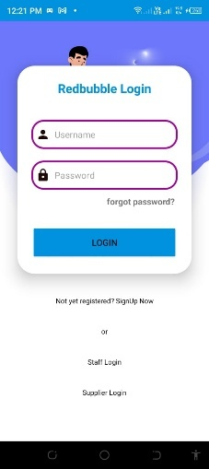

4.2 Administrator Interface
This is where the administrator enters his or her login credentials so as to access the system and oversee the processes within the system.
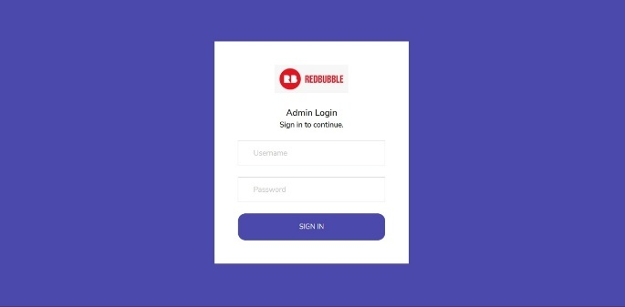

4.3Administrator Dashboard
It includes the main screen where the administrator logs in. The dashboard shows new processes and requirements that the administrator is required to complete. 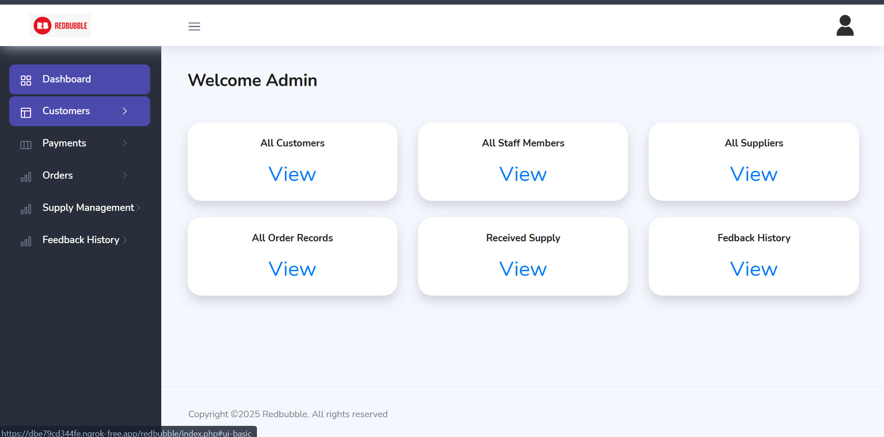

4.4 customer’s interface
It shows the customer dashboard
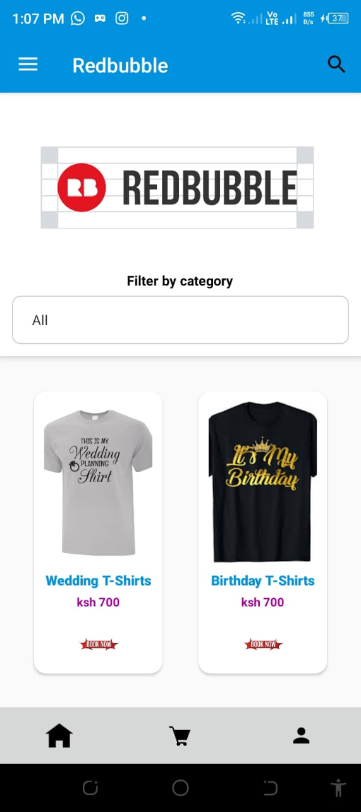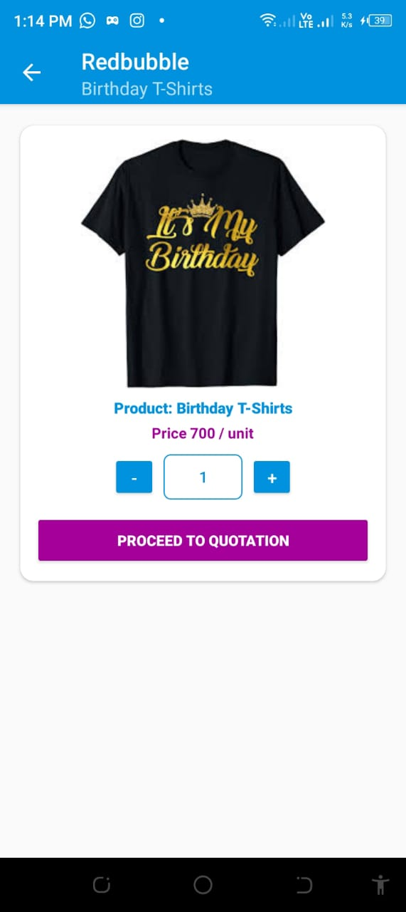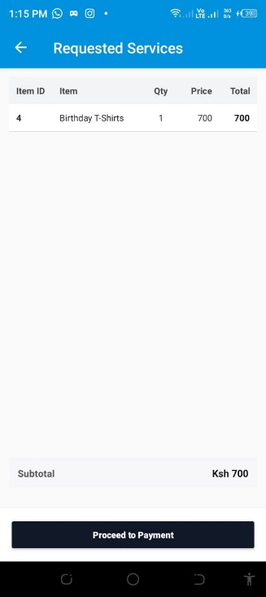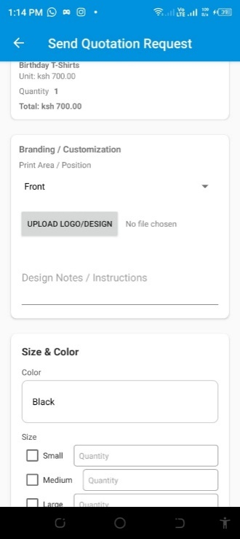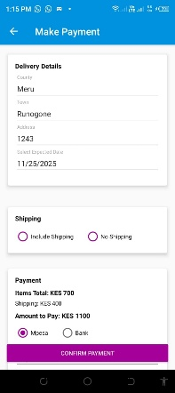

4.5 Supplier’s interface
Shows the names of the suppliers in the administrator interface and how the suppliers get to bid for the available tenders.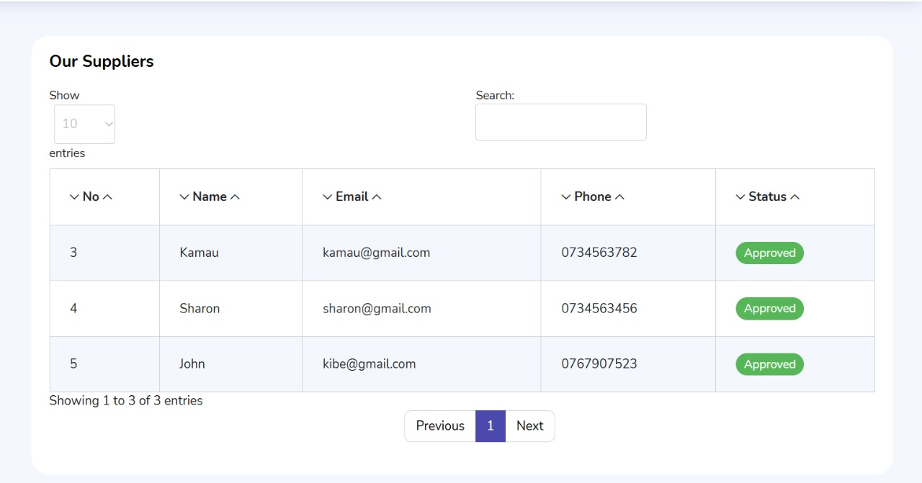
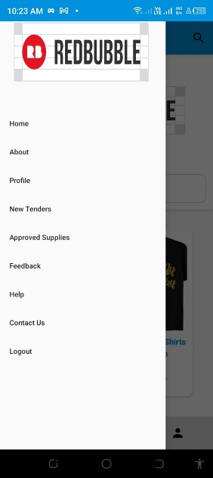

4.6 Database module
The database includes every table used by the system. The system includes various tables as identified from the image below.
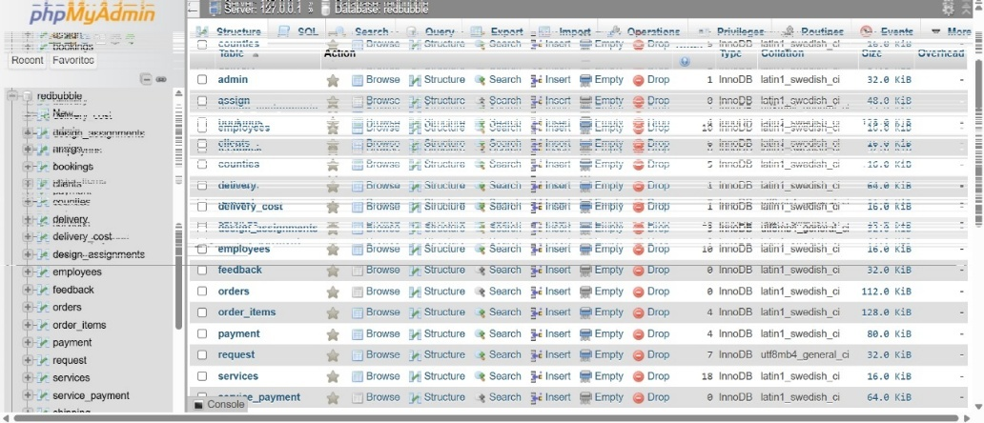

4.7 About Us Module
Communicates the platform’s mission, vision and background to users, enhancing bran credibility. 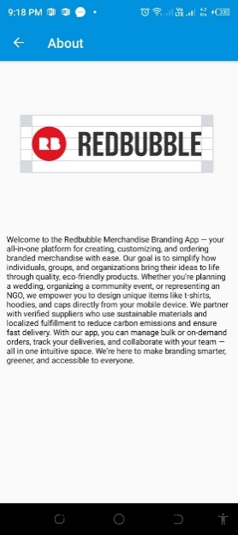

4.8 Help Module
Provides clients and freelancers with access to FAQs, live support and a ticketing system for issue resolution.
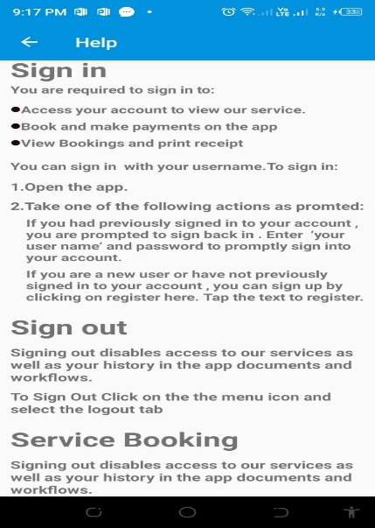

4.9 Drivers Module
Delivers the orders to the customer when a customer requests for shipments of the order.

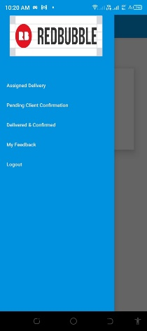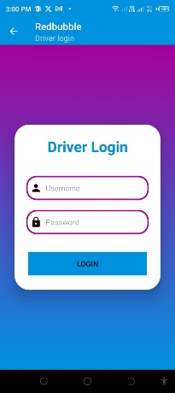

4.10 Service Manager
Allocate the designer and technicians that will be working on the orders
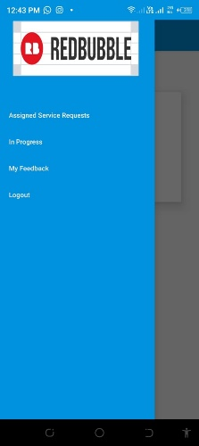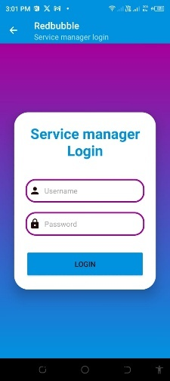

4.11 Technician Interface
Convert designs into products through tasks like assembly, testing and quality checks.
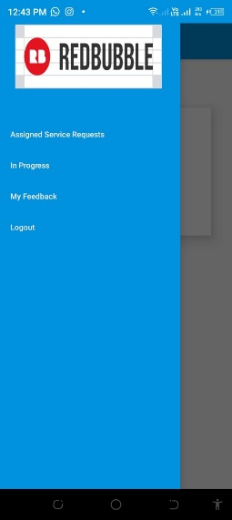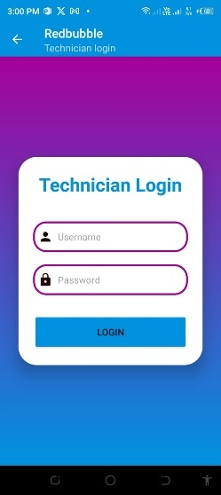

4.12 Feedback and Support Module
Enables users to review services after completion, building trust and accountability with the platform.
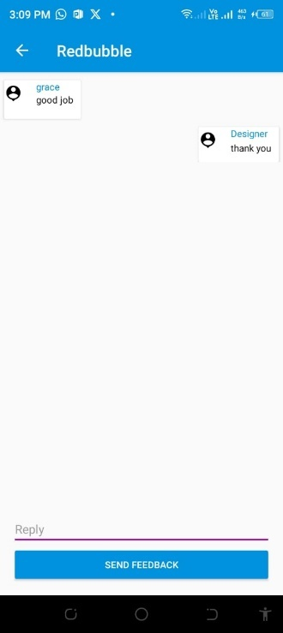

4.13 Dispatch manager
Coordinates efficient orders dispatch by assigning tasks to drivers, routing deliveries on an optimal level and providing real time tracking to administrators and clients.
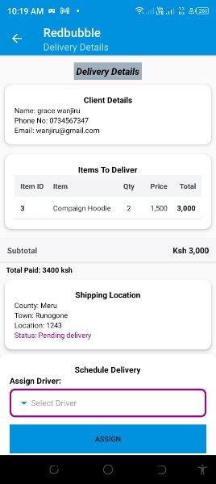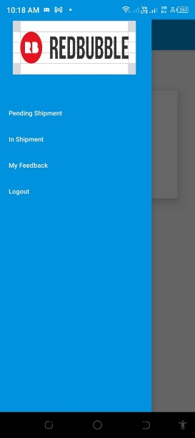

4.14 Designer interface
Tailored specifically for fashion designers to display portfolios, manage orders and interact with clients, the client gets to approve or reject the design that the designer sends to them
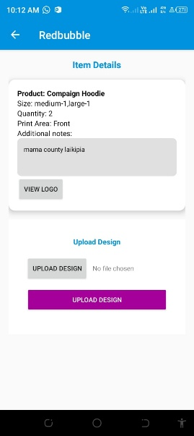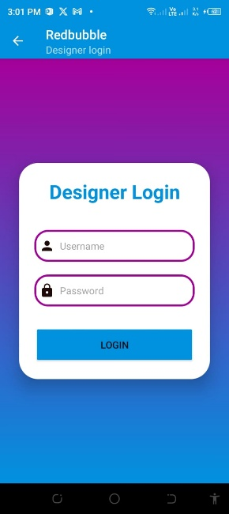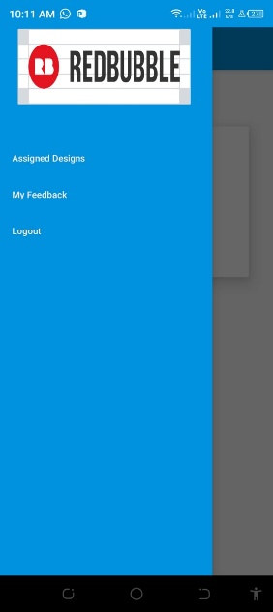

4.15 Stock manager
Manage product inventory levels, ensuring accurate availability during order placement. Also request for new supplies from the suppliers. Stock manager is in charge of ensuring that the materials are released to the technicians upon design approval by the customer.
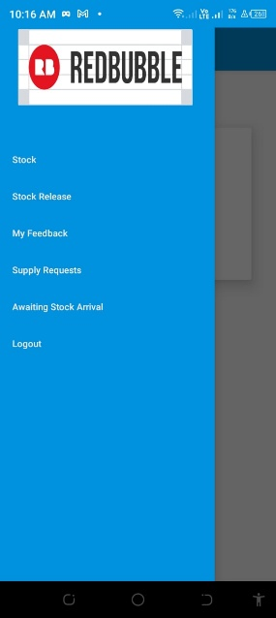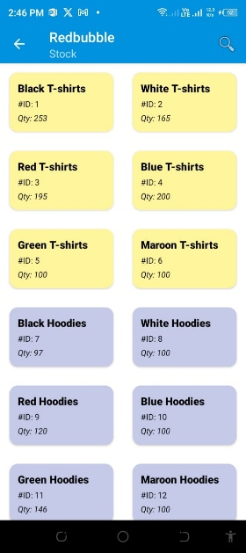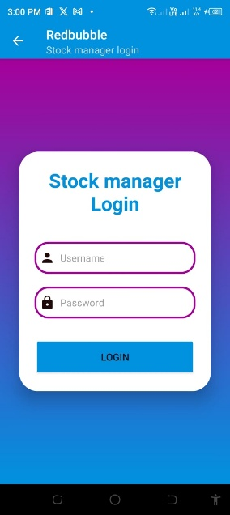

4.16 Reports and receipts module
The reports module allows all authorized users to generate downloadable reports, This helps with decision making and transparency within the organization.
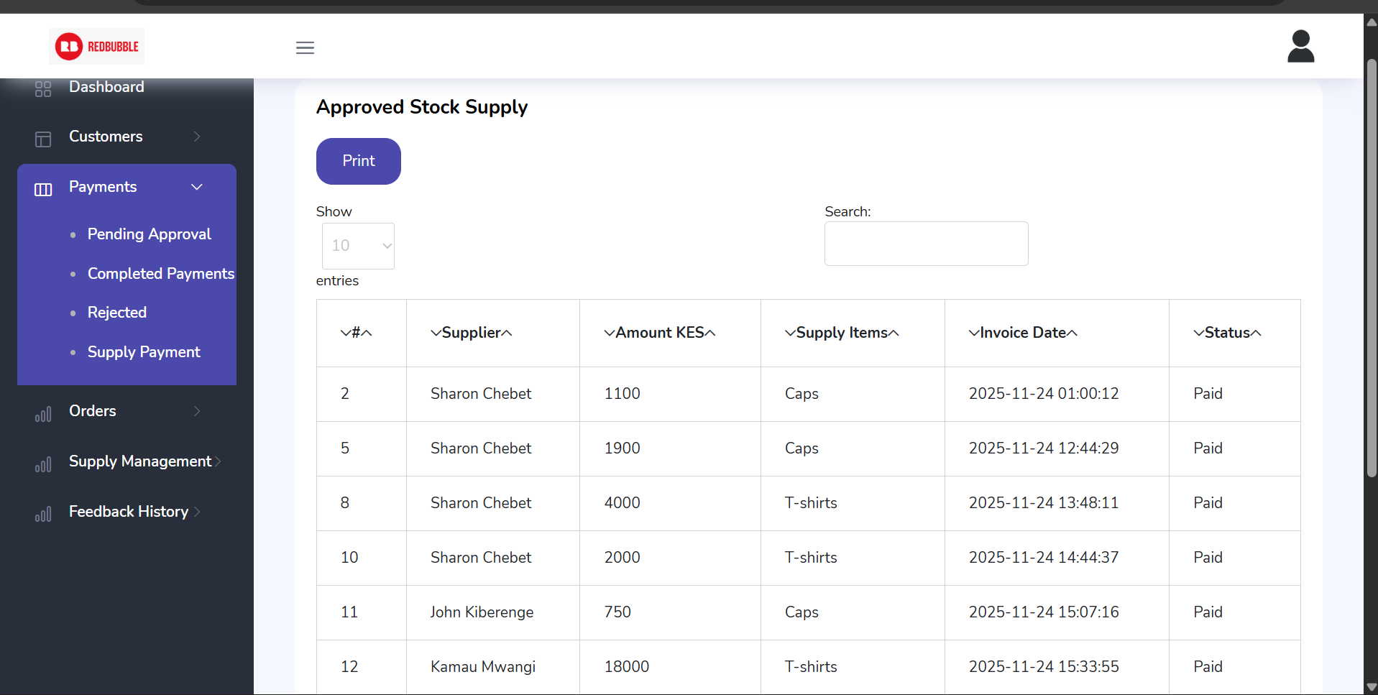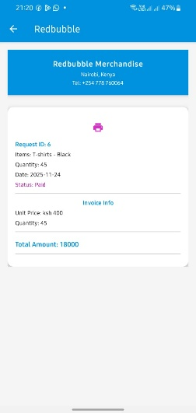

4.17 Payment module
The payment module integrates MPESA or card payments for services such as product purchases and inventory purchase. The system records all transactions and generates digital receipts automatically.

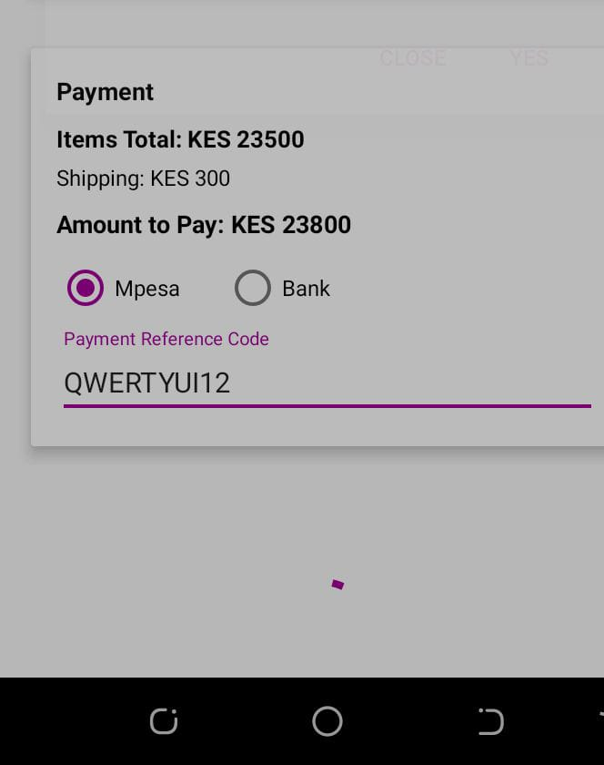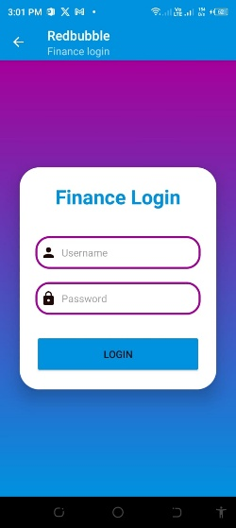

Chapter Five

Conclusion and Recommendation

5.1 Conclusions
The Redbubble Merchandise Branding Mobile Application project reached its set milestones after successfully conducting a feasibility study, requirement analysis and iterative prototyping. The study showed that event organizers, NGOs, and individual customers face fragmented design to delivery workflows, excess stock, and poor visibility. The developed system now integrates design upload, instant quotation, mobile money bank, payment, auto assignment of designer’s technician’s drivers, live order tracking, and digital proof of delivery with a star rating feedback loop all within one Android. Pilot tests conducted with ten orders reported the average delivery time to have decreased from 42 hours to 18 hours, while customer satisfaction was rated at 4.5/5. This platform is modular; comprising customer, finance, service manager, designer, stock-manager, technician, dispatch, driver, and admin modules. It assured scalability and security, thus addressing the identified market gap, while at the same time fostering on demand production and reducing textile waste.

5.2 Recommendations
Such students studying IT related courses should be actively involved in practical sessions and hackathons, since hands on coding, API integration, and hardware interfacing are crucial in doing robust final year projects.
The university should provide subsidized cloud hosting credits, test servers and licensed IDEs for students to deploy production grade systems, not localhost demos.
The curriculum should embed emerging topics, such as print on demand APIs, payment gateway integration, and IoT based tracking, to nurture a problem-solving mindset aligned with Industry 4.0 trends.
The Redbubble application developed should be adopted by the faculty incubator and continuously improved; additional features such as bulk discount algorithms, multi language support and solar powered dispatch tags can be added to widen its commercial viability and environmental impact.

4.0 References
Chen, L., & Zhao, Y. (2021). Enhancing customer engagement through visual merchandising tools in POD platforms: A case of JetPrint. Journal of Design & Technology Integration, 6(3), 91–104.
Johnson, D., & Kumar, S. (2020). Merch by Amazon and the future of content monetization. E-commerce Studies Quarterly, 8(1), 34–45.
Klein, R., & Morris, L. (2020). Challenges of bulk ordering in print-on-demand platforms: A case study of Custom Ink. Journal of E-commerce and User Experience, 12(3), 145–160.
Ochieng, J., & Mwangi, P. (2021). Environmental impact of international shipping: Implications for e-commerce platforms in Africa. African Journal of Sustainable Development, 9(1), 34–48.
Ochieng, P., Mwangi, K., & Barasa, L. (2022). Barriers to e-commerce platform adoption in Sub-Saharan Africa: A Merch by Amazon case study. African Journal of Business and ICT, 7(2), 56–73.
Omondi, R., & Njoroge, T. (2023). Digital fundraising platforms: A case for localization in East Africa. NGO Technology Review, 5(3), 88–104.
Peters, M. (2020). Evaluating print-on-demand platforms: Printful and Teespring in the global market. International Journal of Digital Commerce, 7(2), 90–105.
Smith, A., & Johnson, T. (2021). Bulk ordering inefficiencies on online customization platforms: An analysis of Zazzle. Journal of Retail Technology, 15(4), 210–225.
Taylor, M., & Jordan, A. (2021). Evaluating apparel-based fundraising platforms: The case of Bonfire. Nonprofit Marketing Journal, 7(1), 23–35.

